Johan Hobbs

Abstract

A summary of planned screens and menus for scrap salvager game to be built for DAT602 assessment.

Scrap salvage game

DAT 602 Assessment project

# Brief Description

The player clicks tiles to move around – when the player moves onto a square with an item on it, they can pick the item up. Most items are “Scrap” that can be converted to materials.

The player can use the materials to craft machines or parts, and may sell machines or parts or scrap to an NPC market place, and use the funds to buy different materials or other supplies.

# Main screens

## Login Screen

Player selects their account, enters a password.

If the player enters both their account name and password correctly, they see a list of the characters they can log into the game as.

## Outdoor Zone

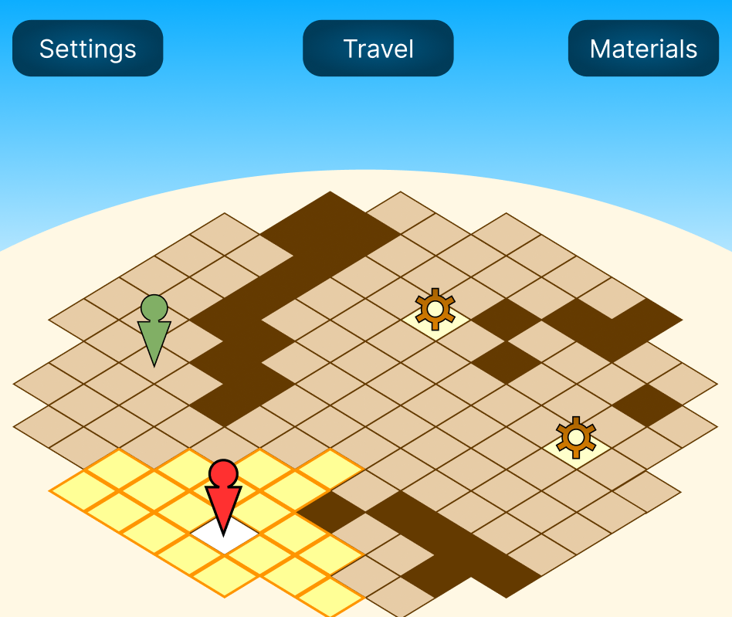

An interactive screen that allows the player to navigate around a “zone”.

The grid, and all visual assets are placeholders now, and are subject to change.

The “sky” part of the map is intended to be an aesthetically pleasing way of reserving a certain amount of screen space for UI elements.

Impassable dark tiles may be either built into the map. The player can not move onto these, but may move around them, and with the required powerups, might be able to “hop” over them.

An icon representing the player is displayed on the map, and tiles that the player is able to move to are highlighted visually. (A red arrow with a circular head is here being used to represent the player.)

When the player has moved, it ends the player’s turn, and any entities controlled by the system can move.

The player can move to a “legal” square by clicking on it.

In the example, a system entity (NPC) is represented by a green arrow with a round head. The player may interact with an NPC by moving to an adjacent tile, and the NPC may interact with a player by moving to them.

Items that can be picked up are displayed on the map as well (represented in the example by “cogwheel” images) – the player or an NPC can pick an item up by moving to an item square.

## NPC interaction

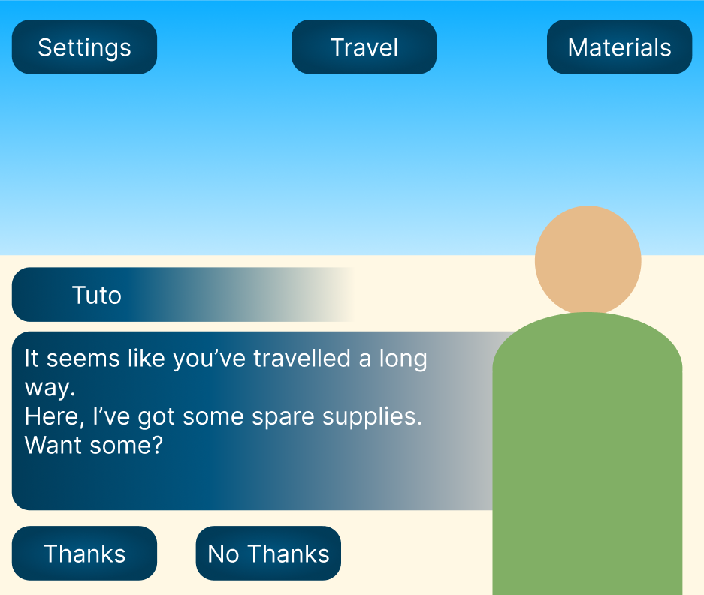

While interacting with an NPC, the NPC portrait should appear, and the NPC’s name should appear above their dialogue box.

Buttons below the dialogue box give the players options to respond.

A player’s dialogue options may have different effects depending on the interaction – for example, in this interaction, the NPC “Tuto” might give the player some resources if the player says “Thanks”.

Each NPC might have a table of potential interactions, including NPC dialogue, available player replies, and the different things that might happen if a player selects a particular option. (For example, the player may gain or lose resources, currency, or NPC friendship value, or gain an item)

## Workshop Zone

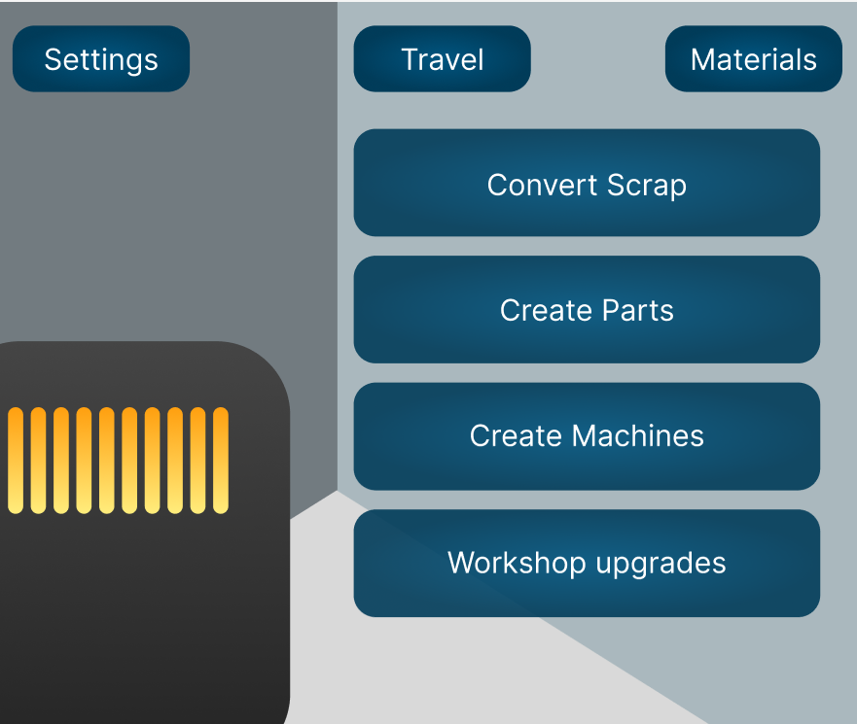

The workshop allows the player to create things from materials that they can obtain by gathering, by trading with NPCs or by

## Travel Menu

A Menu that will allow the player to travel from their current location to another location – for example, from the workshop to the outdoor zone.

## Settings Menu

Adjust things like window colour (Dark mode vs light mode?) difficulty

## Materials menu

A list of all the materials the player currently possesses, including scrap, machine parts, complete machines, and tools. (Menu name should possibly be changed to reflect this)